CCT College Dublin

Assessment Cover Page
To be provided separately as a word doc for students to include with every submission

Module Title: | Programming for DA  Statistics for Data Analytics  Machine Learning for Data Analysis  Data Preparation & Visualisation
Assessment Title: | MSC_DA_CA1
Lecturer Name: | Sam Weiss  Taufique Ahmed/ Marina Iantorno  Muhammad Iqbal  David McQuaid
Student Full Name: | Erwin Plaza Copajira
Student Number: | 2024033
Assessment Due Date: | 08/03/2024
Date of Submission: | 5/04/2024

Declaration

By submitting this assessment, I confirm that I have read the CCT policy on Academic Misconduct and understand the implications of submitting work that is not my own or does not appropriately reference material taken from a third party or other source. I declare it to be my own work and that all material from third parties has been appropriately referenced. I further confirm that this work has not previously been submitted for assessment by myself or someone else in CCT College Dublin or any other higher education institution.

INTRODUCCTION
First of all, I want to make a very important mention about this presentation, as many of our lecturers have told us, the most important thing in the area of data analysis is to understand the context in order to be able to give a solution to the problems that are presented to us. And this project is the best practice to advance in this way of learning the best practices.
++Say something interesting about population
Secondly, it remains to be mentioned that this project has as its priority to analyse population growth in the country of Ireland, taking into account the sex and age of each county.

Statistics is a branch of mathematics that involves the collection, description, analysis and inference of conclusions from quantitative data.

The word statistics contains numerous definitions. In its simplest form, a statistic can be defined as a descriptor of a set of data. The data it collects can be defined as population data or sample data. Data descriptors include its central tendency and its dispersion or variation.
Strictly speaking, you can define the characteristics of population data or sample data.
Descriptors of population data are called population parameters. When it is not feasible to measure the value of a population parameter directly, statistical methods are used to infer the value based on a statistic calculated from a sample taken from the population.
The descriptor of sample data is called a sampling statistic. When a sampling statistic is used to estimate a population parameter, the statistic is called an estimator. A descriptive statistic is used to summarise sample data.

MACHINE LEARNING
- Explain which project management framework (CRISP-DM, KDD or SEMMA) is required for a data science project. Discuss and justify with real-life scenarios. Provide an explanation of why you chose a supervised, unsupervised, or semi-supervised machine learning technique for the dataset you used for ML modeling. [0 - 20]
Framework
According to the documentation provided by the Machine learning course, some documents and papers on the internet, it can be said that these frameworks help to give us a guide on how to develop data mining. Each of them are functional in the processes of each stage, also some of them even have stages that are similar, such as KDD and SEMMA.
Unlike the previous two, CRISP-MD is a very good guide for people who are starting out in the area of data science.
Also, CRISP-DM remains the top methodology for data mining projects, with essentially the same percentage as in 2007 (43% vs 42%). However, it is reported to be used by less than 50%.
Cases applied in real life:
Indeed, to find real examples of the use of CRISP-MD. We have analysed that these are used robustly in IBM projects either for commercial or in-house project development. It is worth mentioning that a case study was also found in the manufacturing environment, and in this specific case those involved found that CRISP-MD is adapted for continuous process improvement by helping company personnel to make better decisions with the use of machine learning.
Stages of CRISP-DM:
- Business/ Research Understanding Phase
- Define project requirements and objectives
- Translate objectives into data exploration problem definition
- Prepare preliminary strategy to meet objectives
- Data Understanding Phase
- Collect data ◦ Perform exploratory data analysis (EDA)
- Assess data quality
- Optionally, select interesting subsets
- Data Preparation Phase
- Prepares for modelling in subsequent phases
- Select cases and variables appropriate for analysis
- Cleanse and prepare data so it is ready for modelling tools
- Perform transformation of certain variables, if needed
- Modelling Phase
- Select and apply one or more modelling techniques
- Calibrate model settings to optimize results
- Evaluation Phase
- Evaluate one or more models for effectiveness
- Determine whether defined objectives achieved
- Make decision regarding data exploration results before deploying to field
- Deployment Phase
- Make use of models created
- Simple deployment example: generate report
- Complex deployment example: implement parallel data exploration effort in another department
- In businesses, customer often carries out deployment based on your model

Flow of CRISP-DM
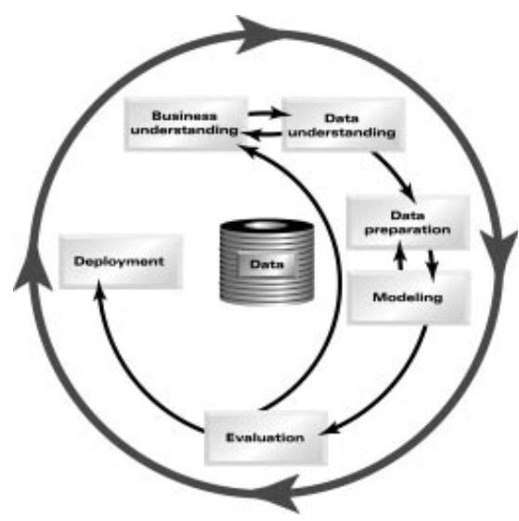
According to the characteristics of the mentioned frameworks, I chose to use CRISP-DM because this is the most advisable to start in the area of data science.

- Research Understanding
+ Hablar acerca del objetivo del proyecto
+ Criterios de éxito
+ estrategia para llegar al objetivo
- Data Understanding
+ Explicación del origen de los datos y cantidad de recursos
+ Identificacion de las Variables claves
+ Analiss EDA´y evaluar la calidad de datos de nuevo
+ Explicacion e impresión de graficos obtenidos de phyton
- Data Preparation
+ Hacer un analisis previo de que modelos podríamos usar
+ Seleccionar los casos para el objetivo
+ Limpiar y preparar los datos para el modelo (Mostrar Codigo)
+ Explicar la normalización y transformación de variables categoricas
- Modelling

Supervised learning
Supervised learning or supervised machine learning, is a subcategory of machine learning. It is defined by the use of labelled datasets to train algorithms that accurately classify data or predict outcomes.

Supervised learning comprises two types of data mining problems: classification and regression:
Classification problems use an algorithm to accurately assign test data into specific categories, such as distinguishing apples from oranges. Or, in real life, supervised learning algorithms can be used to classify spam into a separate folder in your inbox. Linear classifiers, decision trees, support vector machines, and random forests are common types of classification algorithms.
Regression is another type of supervised learning method and it uses an algorithm to realise the relationship between dependent and independent variables. Regression models are useful in predicting numerical values based on different data points, such as sales revenue projections for a given company. Some regression algorithms are linear regression, polynomial regression and logistic regression.
The best practices for choosing the best algorithm for our models are presented in the following flow chart:
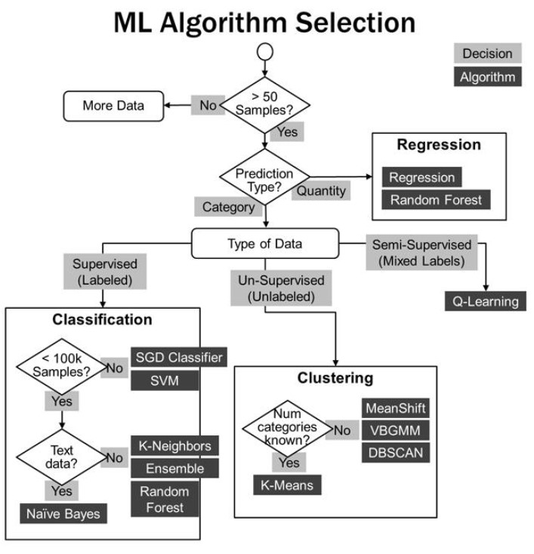

+ Seleccionar y aplicar modleos
+ optmizar modelos
- Evaluation
+ Evaluacion de los modelos usando Preci, recall y F1 score
- Deployment
+ Se implementa el entorno para produccion
+ Mostrar un ejemplo

With regard to this diagram given in the machine learning CCT college course. I have decided to use supervised learning algorithms. Due to the amount of data collected and the categorical data types that my dataset has.

References
Papers
KDD, SEMMA AND CRISP-DM: A PARALLEL OVERVIEW
https://core.ac.uk/download/pdf/47135941.pdf
CRISP-DM, still the top methodology for analytics, data mining, or data science projectshttps://www.kdnuggets.com/2014/10/crisp-dm-top-methodology-analytics-data-mining-data-science-projects.html
Domain Knowledge in CRISP-DM: An Application Case in Manufacturing
https://www.sciencedirect.com/science/article/pii/S2405896323015598

Importance of Statistic
https://ccsuniversity.ac.in/bridge-library/pdf-23/E_Content_INTRODUCTION%20TO%20STATISTICS.pdf

